STATIC ELECTRICITY

Atomic Structure

The structure of the atom has a cloud of electrons orbiting around a nucleus in energy shells.

It is the outer electrons that are involved in the production of static electricity.

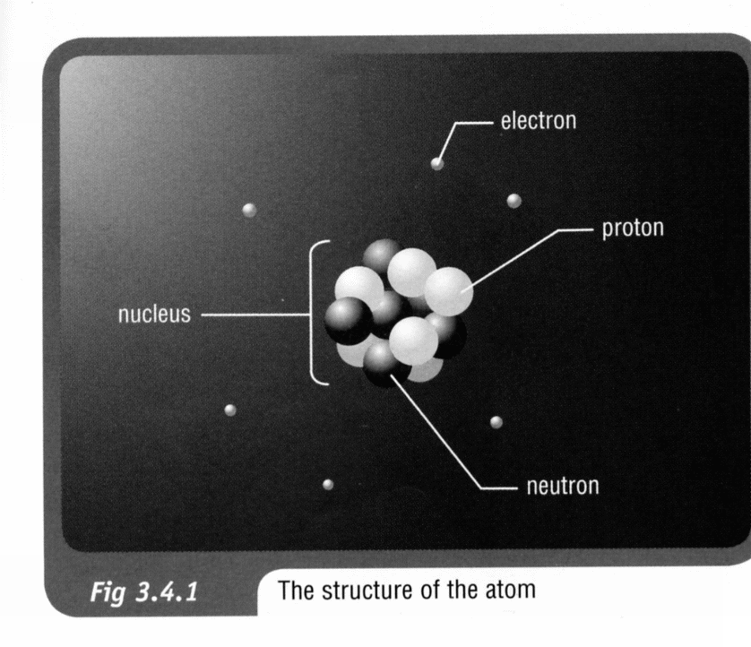

Static Electricity

Friction between two surfaces can rub electrons off one object and onto another.

The object that gains electrons becomes negative - the other becomes positive. This produces static electricity.

Static Electricity: stationary charges on an object.

e.g. A plastic comb rubbed on a cotton cloth becomes positively charged by losing electrons.

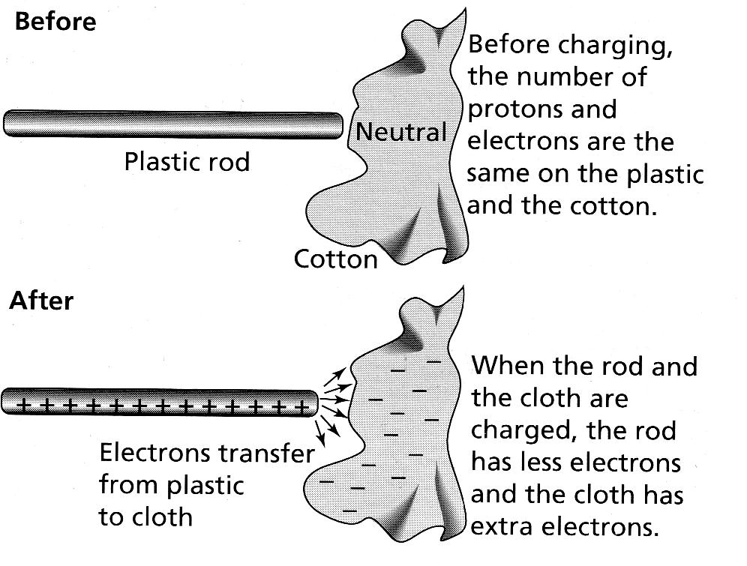

Interaction of Charges

Charge Law: Similar charges repel each other while opposite charges attract each other.
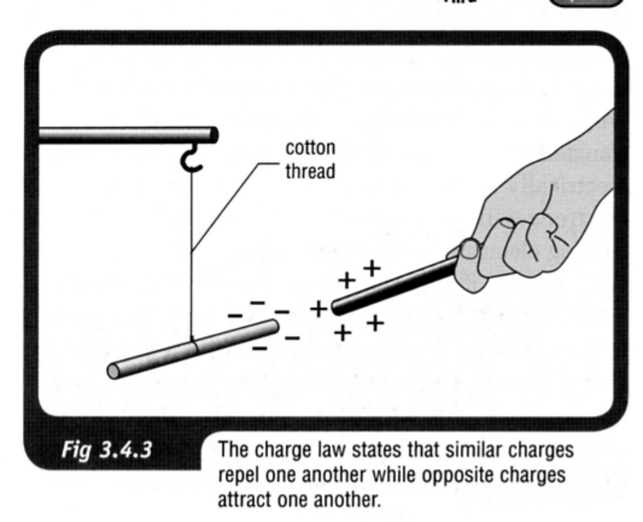

Examples of Static Electricity

Lightning
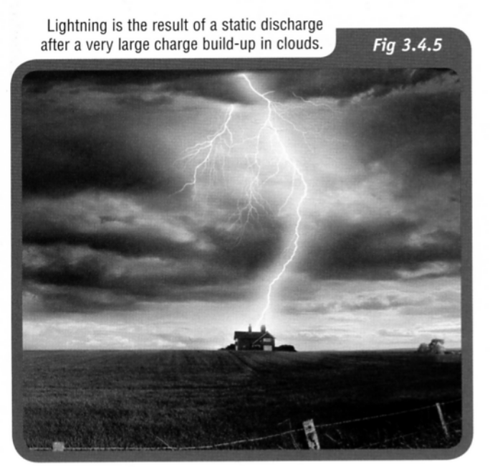
• Caused by the friction between the air and the clouds.
• Convection currents within the cloud also cause ice particles to produce static charge.
• Charge on the ground below the ground becomes oppositely charged.
• Lightning is discharged to the ground or tallest structure with a large charge density.

Pollution Control

• Chimneys have special electrostatic traps to attract smoke particles.
• This reduces the amount reaching the atmosphere.

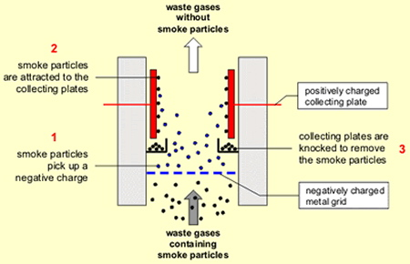

Getting "Zapped"

• Moving cars build up a charge as they move through the air.
• Passengers sometimes get "zapped" as they get out of the car and touch the metal part of the door.
• The charged flows around the person to the Earth.

